Undergraduate Module Delivery Report 06/07
(Guidance notes overleaf)

Module No: IN2009 Module Name: Language Processors

Student Performance & feedback 06/07 [see note 1]:

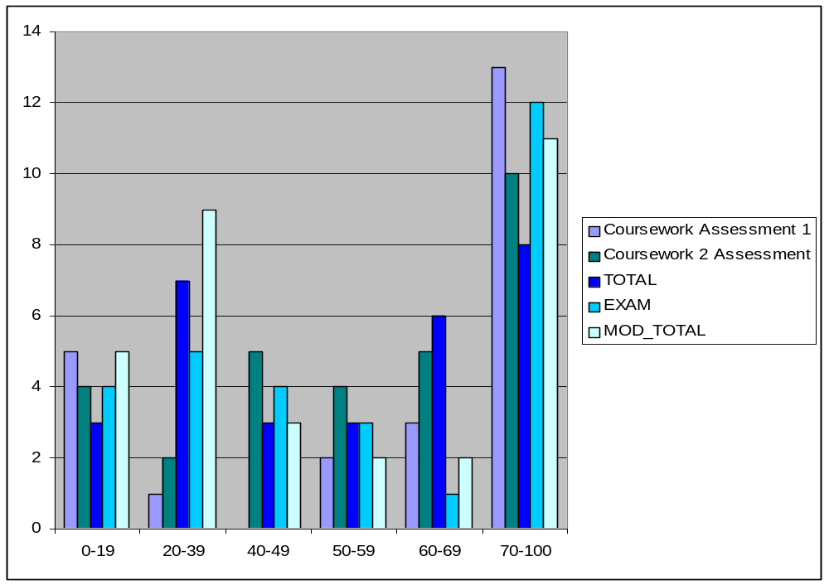Foreword: The statistics presented here are the wholly accurate ones generated from the full set of results and ignoring nil submissions (instead of assuming a mark of zero unlike SITS). Thus they may deviate very slightly from the system-generated statistics from SITS.
Overall stats:
Total number of candidates submitting for any assessment: 32
Total number submitting all assessment components: 22
Total number of Extenuating circumstances granted: 4
Min: 0%

Max: 94.8%
Ave: 51.0%
StDev: 28.1

Detailed breakdown:
 | Coursework 1 | Coursework 2 | Total Coursework | Exam
Submissions | 24 | 30 | 30 (23 submitting all) | 29
Minimum Mark | 5% | 0% | 0% | 13%
Maximum Mark | 100% | 98% | 99% | 94%
Average (mean) | 64.5% | 56% | 53.7% | 56.6%
Standard Deviation | 33.5 | 28.2 | 27.5 | 27.7
This was a small cohort, consisting of all part 2 CS students, with two part 3 elective students and several re-take students. This is traditionally a reasonably tough subject to study, and as such an overall average of just over 50% is appropriate, and there is a good range of marks on all assessments, and a particularly good examination average.

It should be noted that the overall module average was reduced by candidates who submitted only part of the assessment diet (which was 10 candidates, or 31% of the total cohort, an extremely high proportion, and generally due to the retake students, and three students with extenuating circumstances at EC3). There was also an extremely wide range of marks, as shown by the very high standard deviation between marks.

There was a resounding lack of student feedback at the end of the module, with only four students submitting feedback (and of which one was entirely blank). The feedback comprised of one extremely good rating (typically averaging close to 5), one extremely poor rating (typically averaging close to 2) and one mediocre rating (typically averaging between 3 and 4). Qualitative data indicated that some students were unhappy with the coursework assessment scheduling this year, which was perhaps a bit tight.

More time will be left between the deadline for the first assessment (which was extended by one week due to technical issues in a lecture early in the course) and the final assessment, and the assessments more transparently broken into steps of progressing difficulty to aid overall achievement.

Review of last years changes/innovations (06/07) [see note 2]:

Since this was a new subject for the lecturer, there is no comment to be made here.

Are changes required to Programme/Module specification for 07/08? [see note 3]

No.

Briefly describe any other significant changes/innovations proposed for 07/08 [see note 4]

- The coursework assessment diet will be reviewed and reconsidered in terms of specific tasks and timing; students appear to struggle with the current tasks and do not score highly on them despite reasonable examination results.
- The lecture syllabus and schedule will be more evenly spread across the 10 weeks, as there was some “bunching” of material early in the course.

Outline any areas you intend to review during 07/08 [see note 5]

Continue to monitor the achievement in coursework throughout the modules next running and note the effect of the changes proposed above.

Report completed by: Christian Cooper, Visiting Lecturer
Guidance Notes

The module leader is responsible for the completion of the report by the deadline. The module leader can ask the module deliverer to complete the report, if appropriate.

Use the electronic form to run to as many pages as you need.

[1] Student Performance: Please comment on the overall student performance. You should specifically address assessment performance where the exam average is <50% or >65%, or where the c/w average is lower than the exam average or more than 15% higher than the exam average. The module stats, as presented at the internal board, are here:
https://www.soi.city.ac.uk/schoolintranet/secure/teaching/UGinternalboardstats2007.html
Student Feedback: Please comment on positive student experiences as well as any negative feedback. Student feedback can be found here:
https://www.soi.city.ac.uk/schoolintranet/secure/modulefeedback/

[2] Review of changes/innovations (06/07): Please comment on the success (or lack of success) of any changes/innovations introduced in the teaching period being reported upon. Indicate whether these innovations will be retained/discarded/pursued further.

[3] Programme/Module specification changes: Please check the module specification here:
https://www.soi.city.ac.uk/schoolintranet/secure/teaching/mod_specs_2005-6/
If any changes are needed please complete a local amendment form which was attached to the email. Please make sure that the ‘before’ and ‘after’ sections are accurate. Changes to specs cannot be made without this form.

[4] Proposed Changes/Innovations 07/08: Please briefly describe any significant innovations in teaching or assessment that you intend to introduce in 07/08 that do not require a change to the module specification.

[5] Areas for review 07/08: If you intend to undertake a syllabus review or other major review during 07/08 for implementation in subsequent academic years, please briefly indicate the nature of the review.

